Hierarchical Clustering

Agglomerative – Bottom up Approach

Divisive – Up to down Approach

Agglomerative HC

Step1: Make each data point a single-point cluster -> That forms N cluster

Step2: Take two closest data point make them one cluster -> that forms N-1 Clusters

Step3: Take two **closest** clusters and make them one cluster -> that forms N-2 Cluster

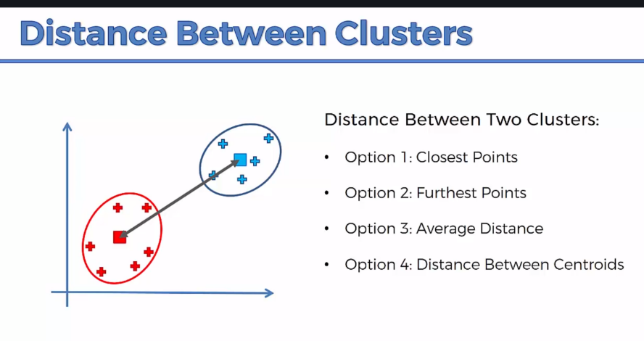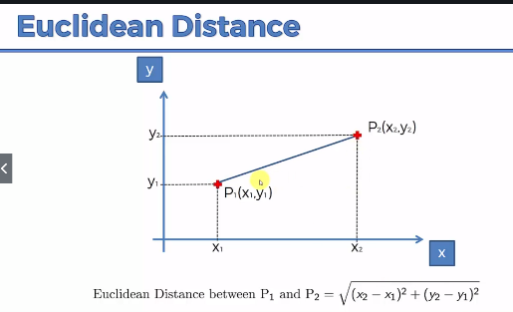Step4: Repeat Step3 until there is only one cluster

Need to understand what do you mean by distance between Clusters

HC Intuition: How do dendograms Work? Dendograms are like memory of every step.

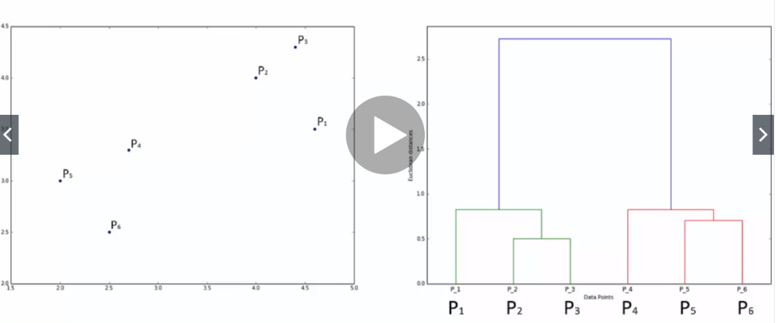The further away you are the more dissimilar they are, so. Dendogram shows how high should the Euclidean Distances

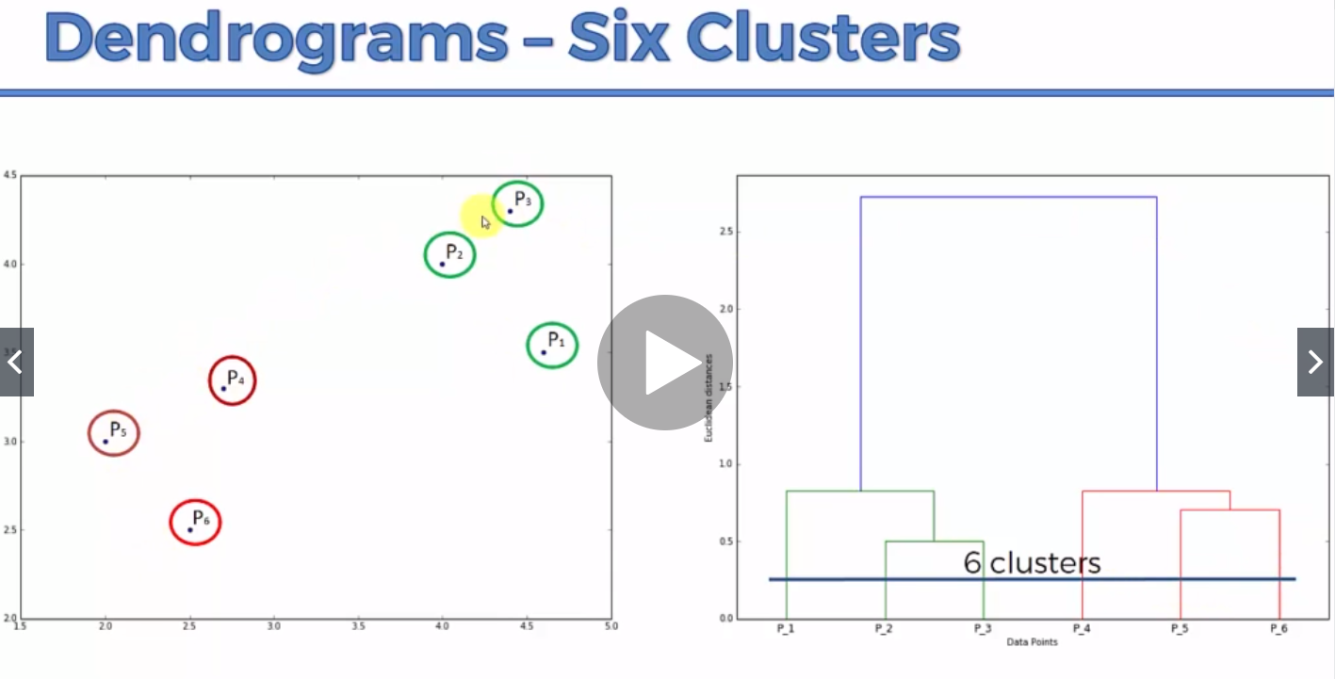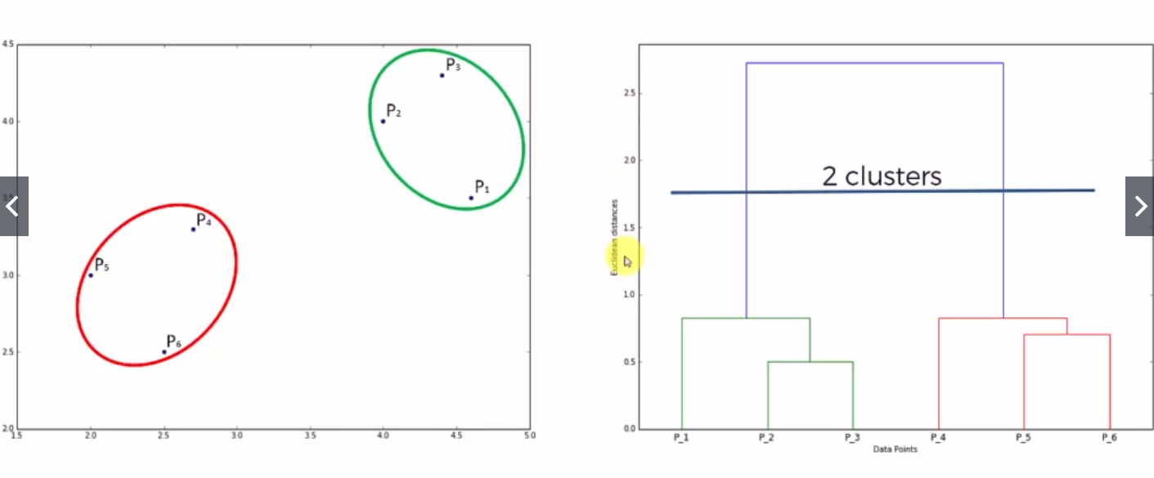HC Intuition: Using Dendograms- Set the Distance/Dissimilarity Threshold. We don’t want this dissimilarities

Find the longest distance that crosses the optimal number of clusters

